AS 402 COURSE SYLLABUS
WN 08
Regional Area Studies
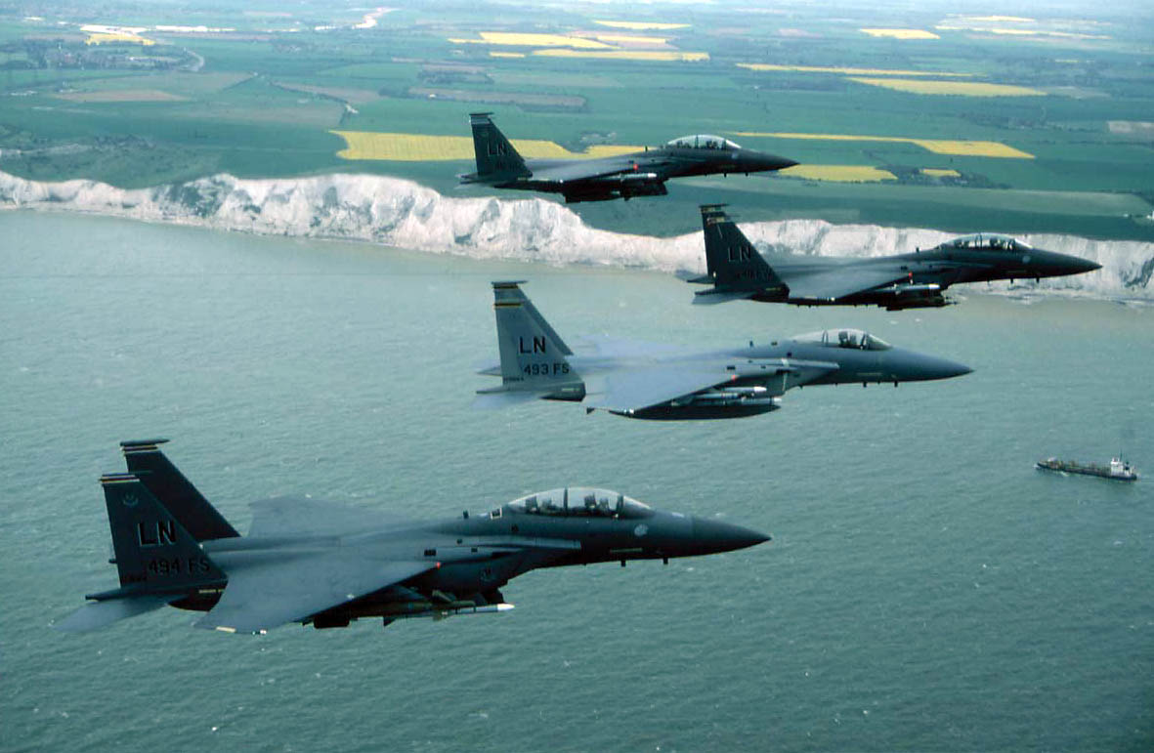
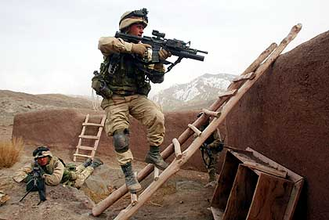

COURSE MEETING TIMES: Tues & Thur 0700 - 0818

INSTRUCTOR: Capt Bill Holl
Office Phone: 292-5441

E-mail: holl.8@osu.edu
Office Hours: By appointment or whenever instructor is available

WELCOME BACK! AS 402 class focuses on gaining a general knowledge of key regions around the world. During AS 402, you will have the opportunity to exercise your communication skills with team presentations on selected international areas.

COURSE GOAL - AS 402
- Better understand the current world situation and various key regions, specifically as they relate to national security and U.S. interests.

GENERAL: General course instructions regarding academic and classroom policies are found in the Aerospace Studies General Course Instructions attached to this syllabus. Note: You must also complete a quarterly counseling with the instructor by 1 Feb 08.

ATTENDANCE & PARTICIPATION (A&P): A&P are 10% of your final grade. Participation includes asking/answering questions, leading class discussions, etc. A minimum of 80% class attendance is MANDATORY for a passing grade. If a conflict arises, please coordinate the excused absence with the instructor before the class period. Any uncoordinated absences will result in an unexcused absence.

REQUIRED TEXTS:
- National Security Affairs & Preparation for Active Duty (T-408)
- Selected Readings in International Security Studies (T-413)
- Tongue & Quill (AFH 33-337)

SUPPLEMENTAL: Supplemental material may be passed out during the quarter. You will be told what is testable in the additional material.

GRADING CRITERIA:

Exam 50%
Group Presentation 40%

Class Participation 10%

Total 100%

ASSIGNMENTS:

a. Exams: There is one exam covering the entire material presented in class to include student-provided SOBs. If you can answer the Samples of Behavior listed at the beginning of each lesson in your Study Guide and the Samples of Behavior provided during the student-led briefings you should do well on the exam.

b. Group Presentation: During the first class session you will be divided into groups of four or five. Each group will teach a lesson which covers one class period on an area of the world starting with “Africa in Transition”. Suggested topics to cover in your briefing can be found in your Student Study Guide but should only be used as a guide. Do your own research to find topics that are relevant to the region today. The grade may be different for members of each team and will be based on the following:
- 40% Content: Adequate coverage of the topic, SOBs, Lesson Objectives
- 30% Organization and Format: includes time limits
- 30% Delivery
- (Note: Each member must present for a minimum of 10-15 minutes)
You should also show and stress the importance of this region to the United States and our National Security Strategy. You will not be graded on how closely you followed the suggested lesson plan but you must cover the Samples of Behavior and ensure the Lesson Objective is met Pro and con positions on whether and how the U.S. should be involved are encouraged.

c. Preparation for class: The study assignments for the lessons covered in class are listed in the Syllabus.

WEARING THE UNIFORM: Wear your uniform to class on Thursday unless excused by the instructor. Comply with Air Force and AFROTC Instructions on proper uniform wear.

AS 402 SCHEDULE

Note: Lessons that double up on one class period will usually continue for part of the proceeding class period.

DATE | TITLE
3 Jan | Intro to AS402: Group Project Instructions & Sign-Up  Pass out books and other assignment material
8 Jan | LSN 44: Information Assurance
10 Jan | LSN 8: Terrorism & Force Protection
15 Jan | LSN 9: Introduction to Cultural Studies (Reading Assignment Only)  LSN 10: Setting the World Stage
17 Jan | LSN 11: Africa in Transition (Lecture / Video)
22 Jan | LSN 20: South Asia in Transition (Lecture / Video)
24 Jan | LSN 22: East Asia in Transition (Lecture / Video)
29 Jan | LSN 26: Latin America in Transition (Lecture / Video)
31 Jan | LSN 33: Europe in Transition (Lecture / Video)
5 Feb | LSN 42: The Middle East in Transition (Lecture / Video)
7 Feb | LSN 49: Russia and the Former Soviet Republics (Lecture / Video)
12 Feb | LSN 11: Africa in Transition (Student Briefings)
14 Feb | LSN 20: South Asia in Transition (Student Briefings)
19 Feb | LSN 22: East Asia in Transition (Student Briefings)
21 Feb | LSN 26: Latin America in Transition (Student Briefings)
26 Feb | LSN 33: Europe in Transition (Student Briefings)
28 Feb | LSN 42: The Middle East in Transition (Student Briefings)
4-Mar | LSN 49: Russia and the Former Soviet Republics (Student Briefings)
6-Mar | FINAL EXAM
10-13 Mar | FINALS WEEK

HAVE A GREAT SPRING BREAK…BE SAFE!

AIR FORCE AEROSPACE STUDIES
GENERAL COURSE INSTRUCTIONS 07-08

PURPOSE: The purpose of the General Course Instructions are to ensure that all Aerospace Studies students are informed on Air Force ROTC and Detachment 645 academic and classroom policies.

CLASSROOM PROCEDURES:
This instruction provides direction on the following important areas:
- Calling the room to attention:
-- Cadets will call the room to attention when the instructor enters and departs the classroom.
- Eating in the classroom:
-- Cadets are allowed to eat and drink during class if it does not disturb class. If a class is disrupted, the privilege will be taken away. This privilege can also be revoked if it creates a mess in the classroom.
- Attendance:
-- 80% attendance is MANDATORY! Less than 80% attendance will result in a failing grade.
-- Written excuse letters are required within 72 hours of absence to be considered by the instructor as an excused absence. The instructor will make a case-by-case determination whether an absence is excused. Oversleeping and minor illness (unless accompanied by note from a medical professional) will not be considered a valid excuse.
-- Whenever possible, cadets will notify their instructors in advance of any circumstances which may cause prolonged absence from class.
- Tardiness:
-- All students are expected to arrive to class on time. Cadets arriving late will enter the class with minimal disruption and promptly take a seat. The cadet will see the instructor immediately after class to explain the tardiness. Instructors will handle tardiness on a case-by-case basis, but the instructor has the option of giving the student zero participation points for the class.

TESTABLE AREAS: The Samples of Behavior (SOB) for each lesson identify the testable material. The information for each SOB will be included in the reading assignments, instructor lectures, guest speakers, handouts, films, or videos.

FINAL EXAMS: Final examinations will normally be taken by the student at the time published by the university for that particular Air Science course. If a particular Air Science course has more than one offered examination time, students may elect to take the final exam at whichever time is most convenient for them. In the event one of these scheduled times does not fit into the student's overall final exam schedule, he/she may request relief from the instructor, and take the exam in the scheduled exam period for one of the other Air Science courses.

ASSIGNMENTS: Assignments are due on the day indicated. Unexcused late submissions WILL result in a lower grade. This will be dealt with on a case-by-case basis, but normally the assignments will be reduced one letter grade per day late.
REQUESTS FOR EXTENSIONS: Students who experience difficulties in meeting course requirements due to unusual circumstances may request time extensions from their instructors. The instructor will consider each situation on a case-by-case basis. Students MUST comply with the established course-required times until the instructor grants a time extension. In short, make NO assumption that the instructor will automatically grant a time extension.

CLASS PARTICIPATION: Class participation is an important GRADED part of all Air Science courses. This grade is based on your attendance and the instructor's evaluation of your preparation, attention, and active participation in class. Being present may not earn you any class participation points – attendance and active involvement are necessary for participation points. Active participation is an essential element of leadership.

INITIAL AND QUARTERLY COUNSELING: All AFROTC cadets will be counseled by their instructor on a quarterly basis. The higher numbered course instructor will conduct counseling for dual-enrolled students. ALL contract/new cadets should have their quarterly/initial counseling completed NOT LATER THAN the following dates:

Autumn 2007 26 October 2007
Winter 2008 1 February 2008
Spring 2008 25 April 2008

Other students will be counseled by the last day of classes and before the start of final exams, or as stipulated by the course instructor. Additional counseling will be scheduled as required. Special students are invited to schedule counseling sessions if desired.

SPECIAL NEEDS: Any student with disabilities who needs accommodation in this course is encouraged to speak with the instructor as soon as possible to make appropriate arrangements for these accommodations.

GRADING CRITERIA: The grade determination criteria applied to all AFROTC Air Science courses is The Ohio State University standard. It is repeated below for informational purposes.

GRADE PERCENTAGE

A 93 – 100

A- 90 – 92.9

B+ 87 – 89.9

B 83 – 86.9

B- 80 – 82.9

C+ 77 – 79.9

C 73 – 76.9

C- 70 – 72.9

D+ 67 – 69.9*

D 60 – 66.9*

E Below 60*

* - Investigate for Disenrollment

